
Roma House League Development Program
Practise plans all ages
Dear Coach, the following is a recommended practise guide based on age and the 60 min suggested time for a session. Younger players U5 have a short attention span so it is important to keep the sessions fun with lots of variety. The older players U7 and up can do slightly more intensive training with more repetition. However, all players like to have fun so it is important to make the session interesting so they continue to develop a love for the game. There is no exact science to coaching. You have to adapt the session so it works for you and the players.
The sessions will be structured as follows:
Use following format for all training sessions
A 10 Min Warm up B 5 min Fun Game C 10 Min Technique D 10 min Shooting E 25 min Game
THE GOLDEN COACHING RULE
AVOID THE 3 L'S
LINES, LAPS, AND LECTURES
How would it feel being the twelfth kid in a line.
No laps. Train sport specific.
The kids came to play soccer. Not to hear a lecture.

Standard warm up for all training sessions week 1 to week 12. 10 min weekly warm up with the ball
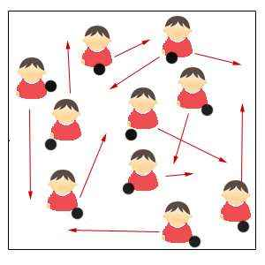
All players in motion with a ball. Head up
moving into space and ball close to body.
Have the players touching the ball inside
and outside of the same foot.
Coach to instruct when to change to weak foot. Use whistle to get Player’s attention to stop or change
A
A
Roma House League Development Program
Variations for standard weekly warm up. 10 min
1) On coaches command ask players to get into groups of 2 or 3 or 4. Player without a partner has to run around the box.
2) Juggle Ball with one foot. Juggle ball with 2 feet. Players can use hands to start. See that players keep moving their planted foot. Have a competition on who can juggle the most at the session or by the end of the season. Give a treat or a small prize.
3) Shuffle ball in motion. Tap ball inside of both feet in motion. Like a pendulum motion. Ask players to increase speed or slow down
4) Sole rolls. Roll ball with sole of foot in motion. Ask the players to keep head up and avoid going outside the box or colliding with a player.
5) Other ways to have fun is blow whistle and ask players to sit on the ball. Right knee on the ball, head on the ball, right elbow on the ball and so on. See who is the last one to follow the command.
6) Toe taps. Tapping the top of the ball with the sole of both feet and alternating left to right foot. Ask the players to move forward or back ward on command.
7) Drag back. Have players moving around the grid and on command or whistle have the players dragging the ball with the sole of their foot behind them and changing direction.
e.g. If the player is right footed have the player put the sole of his foot on the ball and drag it backwards behind him and turn off his/her left shoulder.

Same every week with variations

E
Roma House League Development Program
Standard weekly practise game format 25 min
New Ontario Soccer association Long Term Player Development recommended format. Recreation
Age Group U4 & U5 U6 U7 U8 U9 & U10 U11 & U12
Playing Format Parent & Child 3v3 (No GK) 4v4 (no GK) 4v4 (no GK) 7v7 9v9
5v5 (including GK) (including GK)
(including GK)

U4 & U5 Parent and child participation
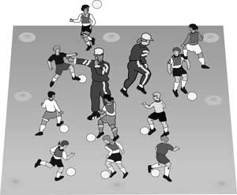
We recommend that Parents participate in drills with their child at this age so they feel comfortable in the training environment. Some children are shy at first so encouragement is always welcomed.

U6 3 v 3 no Goal Keeper
The concept of 3 v 3 soccer and no keepers is to develop creativity and lots of shooting opportunities. The big game is about triangles all over the field. For the young player smaller fields and lower number of players s allows them to work on triangular passing in a lower pressure environment, increases number of touches on the ball and shots on net. This concept will develop more creative and confident players.
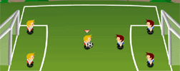
E
Roma House League Development Program
U7 and U8 4 v 4 no GK

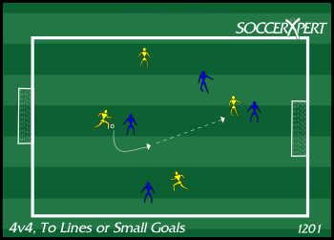
4 v 4 is a progress ion into a real game format.
Diamond formation.
One forward, 2 wide players and one defender.
Still no keepers to encourage lots of shooting.
Players can switch position, work on 1 v 1 ,combination plays and switching the ball left to right. Also, defending. Pressure, cover, balance.
More advanced overlapping runs and buildup play.
Demand players to create width and depth in attack to create space.

U8 Adavanced 4 v 4 and GK

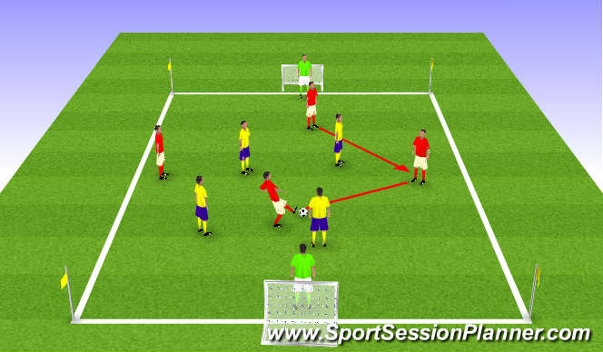
In a game of 4 v 4 and GK the format is the same accept now the players will have to utilize the keeper for playing out of the back. Also developing build up play from the back using the keeper.

Encourage keeper to communicate.

Advanced defending. Goal side. Between the ball and the opposing player .Shift as a unit and compact to take away space from the opposing team.

E
Roma House League Development Program
U9 & U10 7 v 7 with Goal Keeper
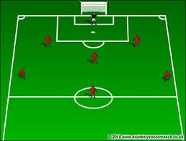
6 players and a GK
2 Defenders , 3 Midfield and 1 forward.
This formation is developing into the real game on a smaller field. Still encouraging lots of touches on the ball and shots on net.
Defenders can overlap and you can work on switching the play through the midfield.
Same principles as previously discussed.
U11 & U12 9 v 9 including Goal Keeper
8 players and a goal keeper.
Recommended formation

2 defenders, 3 midfield and 2 forwards.
With this set up you have 2 forwards attacking the oppositions goal.

Other formation option
3 Defenders, 2 midfield & 3 forwards

Same principles as previously discussed

With 2 forwards work on crossing and finishing with forwards. Near post runs and far post runs.
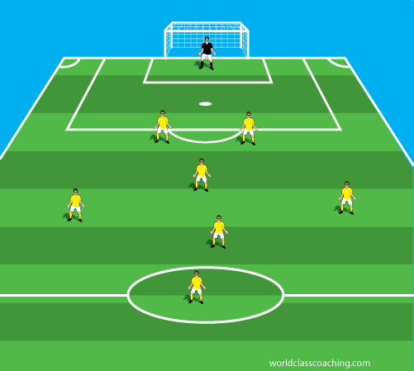
E
Roma House League Development Program
Game situation option for teams of 5 or more on field players.
For teams teams with less players have some conditions like 3 passes before attack, score from a pass, one switch before an attack. All players must be past halfway line when a goal is scored. These conditions can be usd in the larger game forms too.

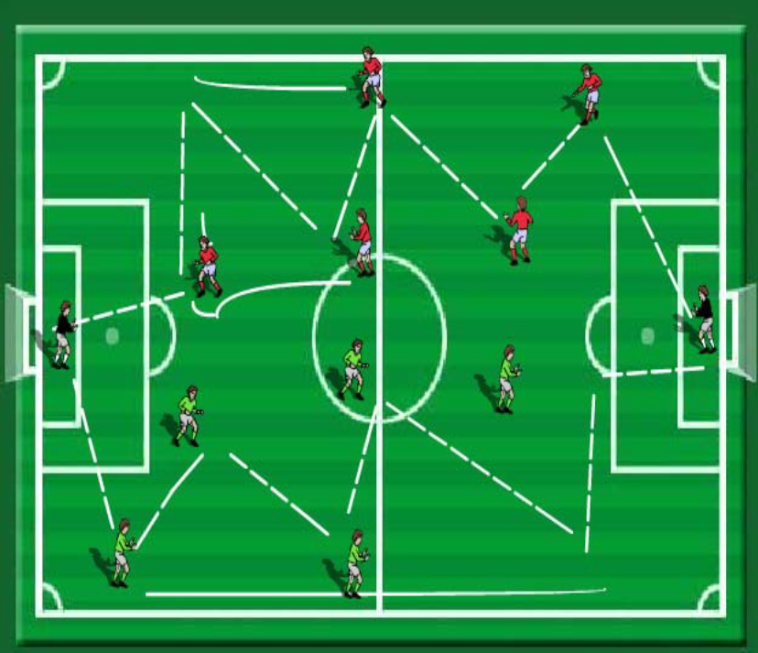
Organization: 5v5 plus Goalkeepers
Balls starts with green team Goalkeeper
Rule is passes must follow sequence of being played –infield then outfield.
In diagram it is played from green full back to center back to outside midfielder then to
overlapping full back that crosses for central striker to score. Once greens attack they jog back to starting positions and Reds begin their attack. In the red example sequence starts from GK to full back to center back to outside mid to central mid back to outside mid who continues his run – played in central but attacker moves out the way for central midfielder to continue a run to goal and shoot. Thus the sequence is different from greens but still within the rules.
Play continues from one end to the other end simultaneously without opposition to start.
Progressions:
Change rule to passes must go forward then backward. This again is designed to tempt an
opponent to be drawn out and then leave space to exploit them in behind.
Introduce opposition – allow 3 of red team to defend against greens and vice versa – now the counter attack option is on if one team does not score the GK can quickly start the counter whilst the opponent is unbalanced. Progress to real game and see if players can realize passing and moving sequences can be developed without any interference from
coaching staff.
Coaching Points:
Speed of play should be same as in a regular game – quick passes and combinations –
The whole team moves and supports and transitions.
Play is not rigid or set – encourage creativity with overlaps –under laps –give and go’s etc.
Ball should always be kept moving – by playing inside –outside in a real game we would drawing the opposition and tempting them – leaving space for the switch or an opening to
exploit scoring chances.

B
Roma House League Development Program
Week 1 Theme Passing
Fun Game 5 min Passing Game: VALLEY OF DOOM
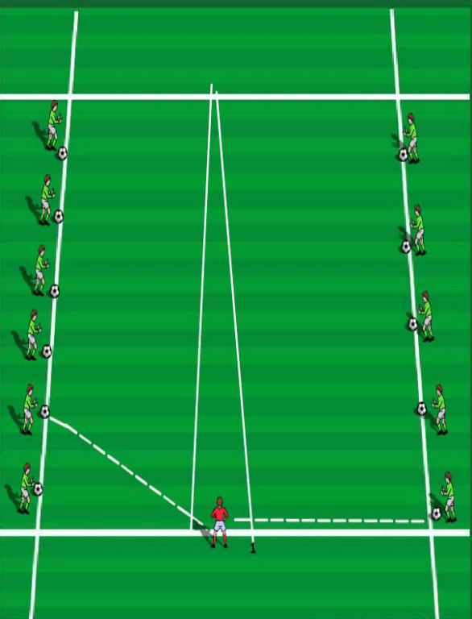
Week 1 Passing in Zig Zag formation 10 Min Technique
X 2 X4 X6
Players in line have a ball each. X1 passes to X2 and X2 to X 3 and so forth. X1 follows his path to X2’s position and other players repeat. X6 dribbles to back of line and process continues. Focus on quality of pass, 2 touch, and ball always in motion. Also, communication.

XXXX
X1 X3 X5
C
Pass
Movement X Player Cone
D
Roma House League Development Program
Week 1 10 min Passing and Shooting
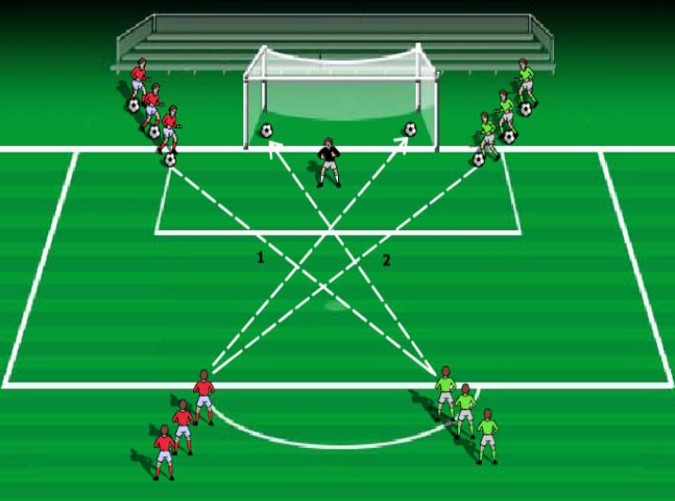
Handy Hint:
Often coaches will do shooting drills
with only one line of players and
make passes into the coach who then passes back for players to shoot. The problem with
this is players are involved very infrequently
and in a squad of 12 players they shoot once
every 12 times. If coaches can split organization
up – as in this drill – now they will shoot
or pass one in every three attempts and are always moving not standing and waiting and
becoming disinterested.
Organization:
4 lines of equal player’s positioned around penalty area as shown above – GK in goal
Ball is served from behind goal on one side of
the net – diagonally across for first player
to shoot first time if possible at goal as s
hown in (1). Striker fetches ball and swaps
position with server – making sure not to run in front of the goal. Opposite side now goes as shown in (2).
Players alternate and after about ten attempts
each from each side – swap players over so
they get to shoot from opposite side of the area.
Coaching Points:
Quality of Pass – firm and accurate but not so
hard they can not hit first time at goal
Striker should angle body shape to the ball – non kicking foot and same shoulder pointed
towards the target. Strike ball ideally on the laces (knuckle of the big toe)
Aim back across the goal towards the far post.
If power is on the pass from server – maybe
just try and pass ball back across goal –
don’t meet power with power!!!
Progressions:
Allow server to pressure the shot
–limiting striker’s time to prepare
Move to shipped or fully crossed passes if ability allows Change angle of service

.

E 25 min Game. Same every week with variations as per pages 3,4,5 and 6.
B
Roma House League Development Program
Week 2 Theme Passing
Organization:
Two teams make a circle separated down the middle as shown in diagram.
Every player has a ball with a different colored or marked ball (the pinball) in the center Players pass their ball and have to try and hit PINBALL so that it goes out of the circle in
the opponents half. Players collect balls that get fired into their half and keep aiming for the pinball until one team wins.
Fun Game 5 min Passing Game: PINBALL

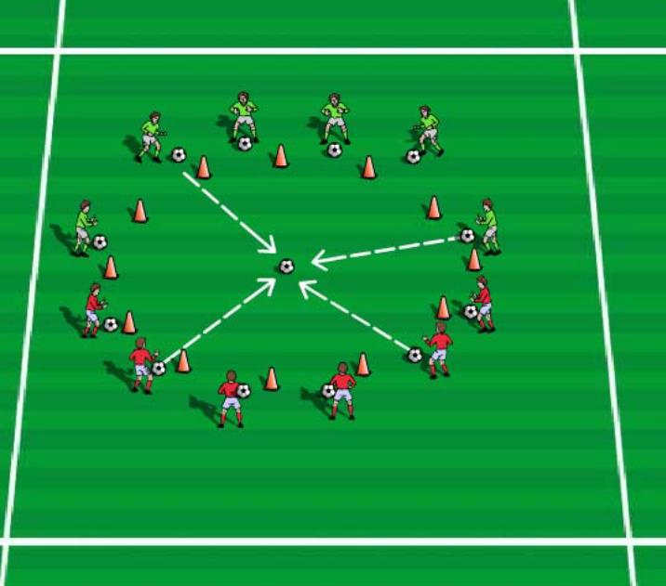
Coaching Points:
Use the inside of the foot
Lock the ankle and follow through to PINBALL target Fetch balls quickly and make sure you aim from outside the circle
– no one can actually kick the PINBALL.
Progression:
Condition passing foot if ability allows.
Increase diameter of the circle to make players pass a greater distance –if ability allows

Week 2 Passing in pairs through gates 10 Min Technique
Players pass ball back and forth. You decide what distance from the gate works for your players. Ball circulates through gates as per diagram left to right in a square formation.
Player receiving the ball can take a first touch to the side with the inside or outside of either foot.
Alternate from left to right. If players have difficulty they can pass back and forth through one gate in a straight line.
Key points
Eye on the ball
Part of the foot and ball
Ankle locked (direction of ankle depends on type of pass)
Follow through -Pace / Timing / Weight of the pass

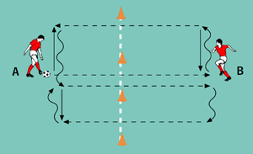
C
D
Roma House League Development Program

Week 2 10 min Passing and Shooting

Shooting drill 1 Shooting drill 2 Progression
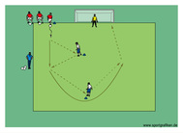
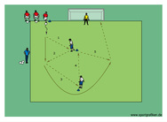
Drill 1 Have 2 players or coaches in the middle 5 yds a part as per diagrams. They will be used for wall passes and lay off for a shot.
Players with a ball each on the end line beside the goal. They dribble up do a wall pass( Give and Go) with the first player. Pass to the second player and then over lap for a shot on net from a layoff pass from the second player.

Drill 2 Progression . Same as first drill. Except that the supporting players do an extra pass and first player is the set up person for the shooters.

E 25 min Game. Same every week with variations as per pages 3,4,5 and 6.
B
Roma House League Development Program
Week 3 Theme Passing
Fun Game 5 min Passing Game: Torpedo
Team in pairs with a ball between 2 players about 10 yards apart facing each other.
Have balls on each side alternating sides as per diagram.
One set of pairs will go on the opposite side. Their objective is to get the ball across the channel without their ball being hit by the players who try to torpedo their ball.
Each pair gets 3 tries before changing or they can continue until their ball is hit.
Players have to focus on timing and accuracy of their passes.
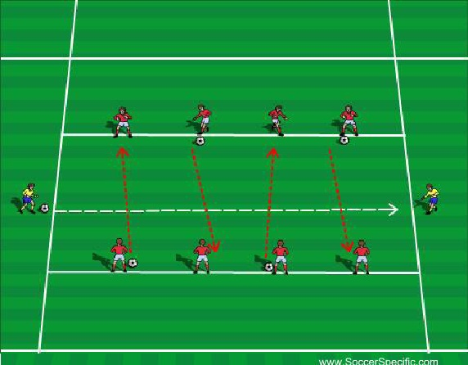
Week 3 Passing Into space and support box drill 10 Min Technique
C

5) Passing into space
X1 X2 X1 (Repeat)

X3 X3 X2
X3 starts with ball
X2 runs to cone that is open and X3 makes a timed pass
To X2. Now X1 runs to open cone and X2 makes a timed pass. Focus on quality of pass, timing and communication
C
Roma House League Development Program
Week 3 Passing Into space and support box drill 10 Min Technique (Progression)
We now have a 3 v 1 situation. Players now have to make proper decisions and support player on the ball by moving side to side.
O1 is a defender and will work hard to win the ball. O1 will replace player he intercepts the ball from. Players now have to make a decision whether to pass to open player or to space.
What happens if defender O1 tries to play smart and stand near the empty cone ?
The game is about possession and support in many triangles all over the field.
Variations can be to have players use different parts of the foot. Teach them to shield and disguise passes
With opposition O1
X1 X2

O1
X3

D

Week 3 10 min Wall Passing and Shooting

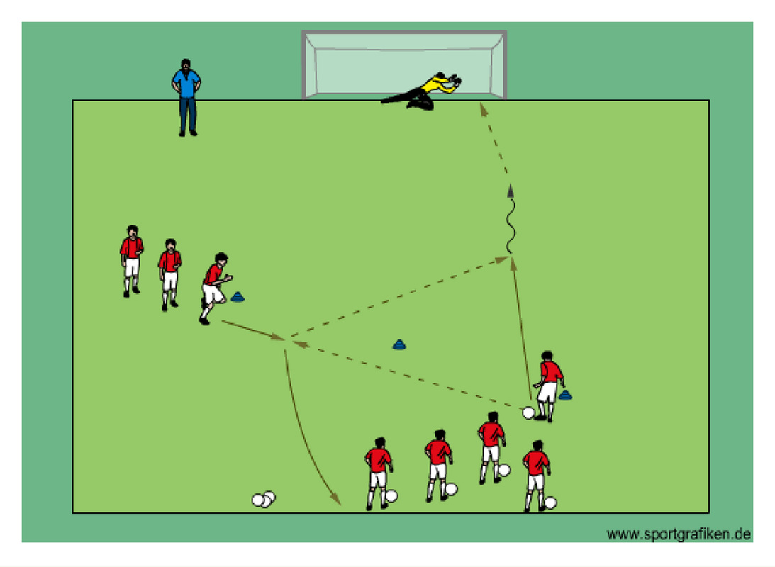
2 lines. One with balls and one with out as per
Diagram. Perform a Wall pass with player with out the ball, receive and then shoot.
Assume the cone is a player. Time pass and change of speed to receive. Supporting player should give an accurate

E 25 min Game. Same every week with variations as per pages 3,4,5 and 6.
B
Roma House League Development Program
Week 4 Theme Dribbling
Fun Game 5 min Dribbling Race game.
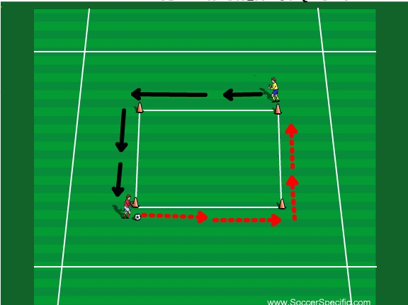
Put players into 2 teams. All with a ball each.
2 players step up with a ball and start at opposite corners.
On coaches command they dribble around the square back to their starting point. The first one back wins. Keep points for each team.
When dribbling the ball should be close to the players foot, lots of touches with laces, and good strides. On bends sharp cuts and change of speed.
C Week 4 dribbling 10 Min Technique

Cross Country
2 teams. All players with a Ball.
Players lined up as per diagram with a bit of space in between.
On coaches command players dribble across the field and back to their starting point. First team player back gets a point. First team to 5 points wins.
Coach can ask players to use inside outside of right foot or left foot or both feet.
Coaching Points:
• head up
• close control
• agility and balance
• soft touches
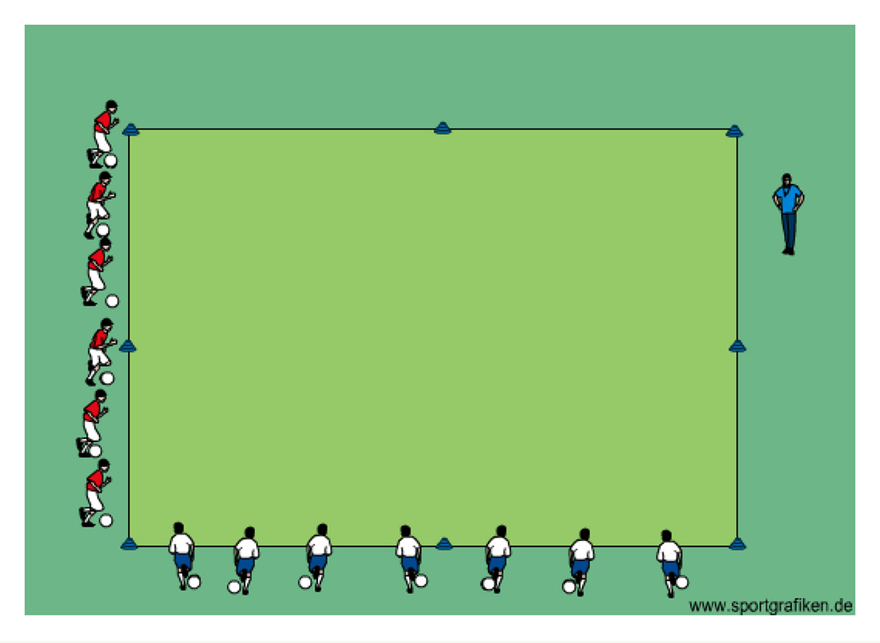
Roma House League Development Program
D Week 4 10 min Dribbling and Shooting

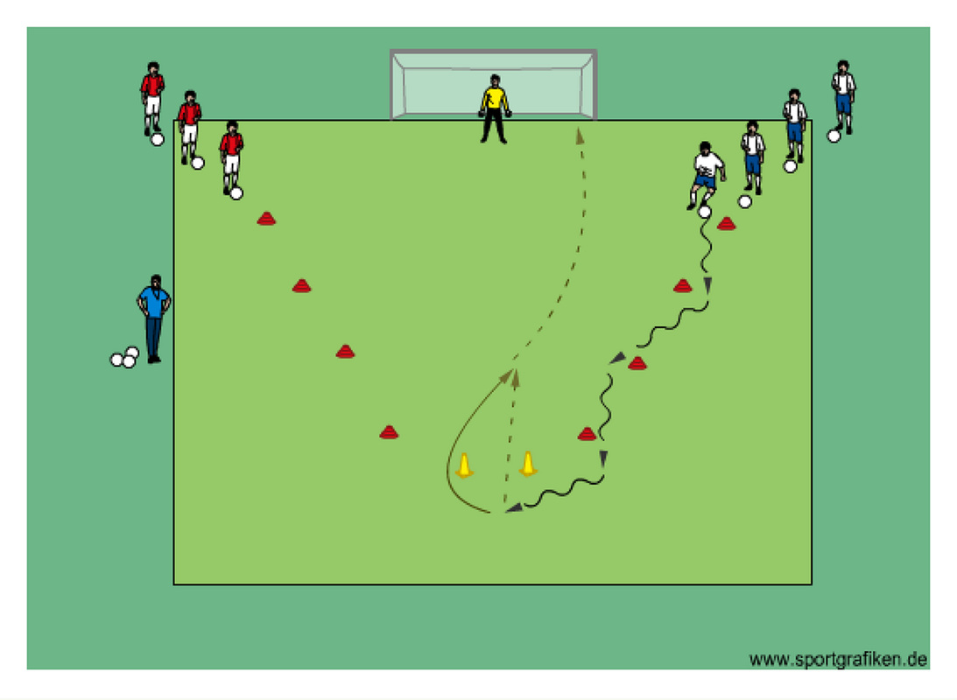

Players line up in 2 lines with a ball each.
One line is for right foot and the other for left foot.
Player dribbles to the top ,passes through the gate, runs around the cone and shoots. Focus on quality dribbling as in technical session, quality pass and accurate shot on net.

E 25 min Game. Same every week with variations as per pages 3,4,5 and 6.
B
Roma House League Development Program
Week 5 Theme Dribbling
Fun Game 5 min Dribbling Cannon Ball
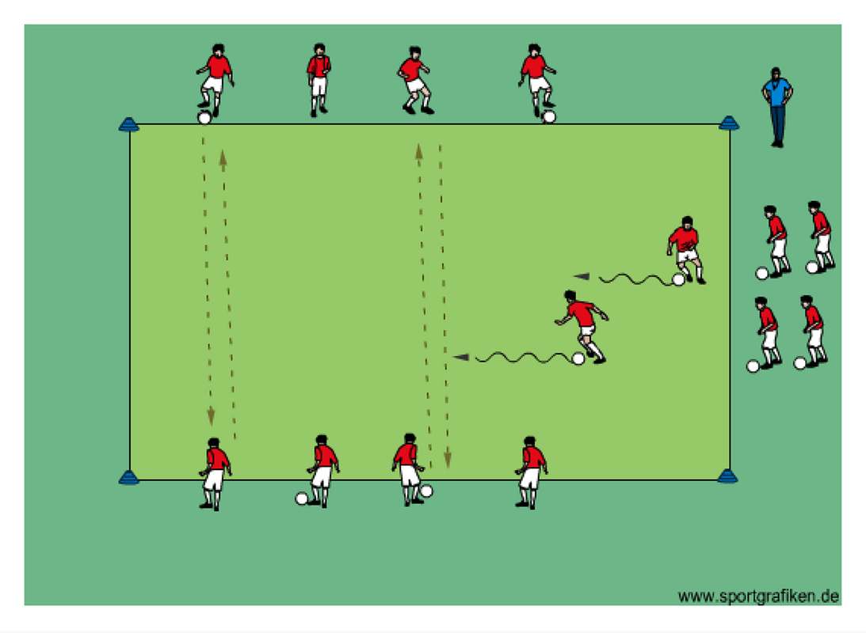
Field Preparation:
• 2 groups
• grid (20yds x 30yds)
• cones to mark off area
• good supply of balls
Description:
• in pairs
• players pass to their partner on opposite side
• 2 players at one time attempt to dribble across grid without being hit
• pass giver with most hits wins
• switch roles
C Week 5 dribbling 10 Min Technique
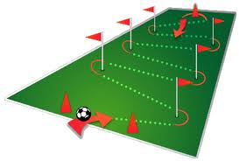
Players dribble ball through slalom. Focus on dribbling with strong foot and close control. Change of speed when turning around cones or flag posts. You can ask player to use week foot and then both feet.

Adavnced. Ask players to do a move at turns. E.g. inside foot chop,outside foot cut or cut behind supporting foot.

Progression set up 2 slaloms and make it a race.

Roma House League Development Program
D Week 5 10 min Dribbling and Shooting completive race.
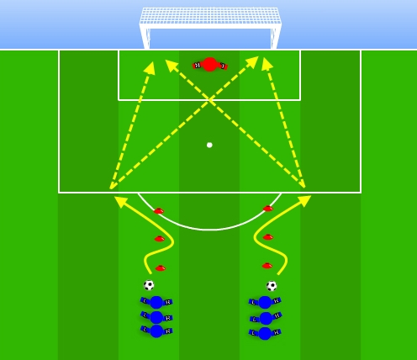
Dribbling race into a shot.
I would recommend having a coach in net or leaving the goal net open.
On coaches command players will dribble through slalom and attempt shot on net. Player first to score gets a point. Winner first one to 3 points.
Progression. After slalom players can cross over before shooting and sprint to end line.
As per technical session ask players to use strong foot, weak foot or both feet. Accuracy of shot before power.

"Why are exceptional dribblers a rare commodity at the higher levels? Probably because players are so often discouraged from dribbling in their early years, which is like telling toddlers to shut up when they're learning to speak."

E 25 min Game. Same every week with variations as per pages 3,4,5 and 6.
Roma House League Development Program
B Week 6 Theme Dribbling
Fun Game 5 min Dribbling TAG
• all players dribble the ball inside the grid
• the tagger carries a pinnie and attempts to tag other players with the pinnie (he cannot throw it)
• if a player is tagged he takes over the pinnie from the tagger and becomes the tagger himself
• on coach's command all players leave their balls and the game becomes a regular game of tag without balls
Options. Have 2 Taggers. Ask players to perform specific dribbling skills. (inside or outside of foot, left or right foot only etc.)
Coaching Points:
• deception • setting up defender
• change of speed & direction • close control
• vision

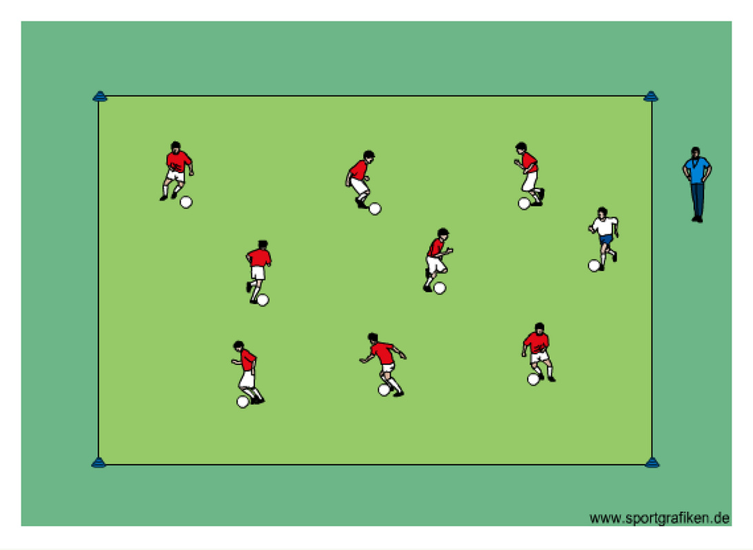
C Week 6 dribbling through gates.10 Min Technique
Set up 2 courses like the diagram and 2 groups. Players dribble through the course through each gate.
Option. If coach has different coloured cones e.g. Yellw and orange. He/she can set up 2 courses within each grid.
He/she can demand the players to dribble through a specific colour course. Once the players have mastered the techniques as in technical sessions coach can challenge the group to a competitive race.
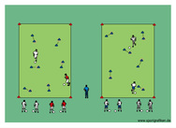
Roma House League Development Program
D Week 6 10 min Dribbling and Shooting Stop watch Finishing
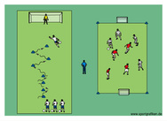
Field Preparation:
• 3 teams
• cones to mark off area
• pinnies
Description:
• 2 teams scrimmage on small field
• scrimmage lasts until third team scores 10 goals
• next rotate teams
Variation:
• specify how players must shoot (left or right foot, inside or laces, high or low etc.)
• rotate teams every 3-5 minutes
• adjust spacing depending on the age and ability of the group if necessary
For the game see that the players have good shape e.g. Diamond if they play 4 v 4
*Note If you do not have enough players for session just do the dribbling and shooting part. Have the players dribble until the first players scores 3 goals.

'ARTISTRY AND POTENTIAL'
"At a youth soccer game you'll probably hear parents and coaches on the sidelines yelling, 'Pass the ball! Pass the ball!' ... When we continually tell our young players to pass the ball, we're not allowing them to develop their full potential, especially those who have the ability to take their opponents on and beat them one-on-one. As a result, we run the risk of diminishing a player's artistry and potential."

E 25 min Game. Same every week with variations as per pages 3,4,5 and 6.
Roma House League Development Program
B Week 7 Theme Passing
Fun Game 5 min Moving goals
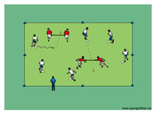
Field Preparation:
• each player with a ball except for target players
• grid (20yds x 30yds)
• cones to mark off area
• pinnies
Description:
• target players hold a pinnie between them and move around the grid (Use hands, jacket or Rope as alternative)
• players dribble and try to score by passing between target players
• rotate target players
• player to score most goals within 90 seconds wins
Variation:
• add one or two defenders
• no point is awarded once the ball leaves the grid after a pass
• attackers have only one or two balls which they have pass to each other and between targets to score a point
• adjust spacing depending on the age and ability of the group if necessary
C Week 7 Passing 10 Min Technique
Field Preparation
• in pairs • each pair with a ball • grid (30yds x 30yds)
• cones to mark off area • cone gates (2-4yds)
• pinnies for defenders to carry
Description:
• players attempt to pass through gates to their partner
• two defenders (red) try to intercept passes
• if ball is won by a defender he gives it right back
• players can't score on same gate twice in a row
• pair to make 15 passes first wins
Variation:
• add defender(s) • players must make 2 (3) passes through a gate to score before moving on to another gate
• pair to make most passes within 90 sec. wins
• adjust spacing depending on the age and ability of the group
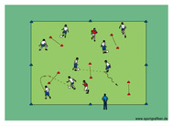
Roma House League Development Program
Coaching Points:
• weight of pass
• accuracy
• vision
• constant movement
D Week 7 10 min Passing and Shooting
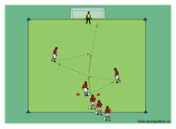
Description:
• players pass and finish on goal in the sequence as shown
• players switch sides after 4-5 minutes
You can use coaches as an alternative.
Variation:
• one touch for all players
• adjust spacing depending on the age and ability of the group
Coaching Points:
• body mechanics and control of body
• body position and balance
• eye on ball
• quality of preparation touch
• contact surface
• aggressive and positive mentality
• placement versus power

"The game is the best teacher. The coach is really a substitute voice. We want the players to hear the silent voice, the game. The game is actually talking to you."

E 25 min Game. Same every week with variations as per pages 3,4,5 and 6.
Roma House League Development Program
B Week 8 Theme Passing
Fun Game 5 min PAC MAN
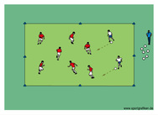
Description:
• two players (Pacmen) start with a ball
• Pacmen try to pass against other players below the knee
• if player is hit he takes a ball and becomes a "Pacman" as well
• last player without a ball wins and starts as a Pacman the next round
Coaching Points:
• stay within bounds • keep ball rolling
• head up • vision
• change direction and speed • fake passes
• close control • agility and balance
C Week 8 Passing in pairs 10 Min Technique
Description:
• players pass to each other in the sequence as shown
• players switch starting positions each turn
Variation:
• limit number of touches
• specify how players must pass/receive (left or right foot, inside or outside foot etc.)
• adjust spacing depending on the age and ability of the group
Coaching Points:
• body mechanics
• balance
• weight of pass
• accuracy
• first touch
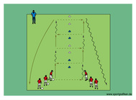
Roma House League Development Program
D Week 8 10 min 2 v 2 Passing and Shooting (Attacking and Defending play)
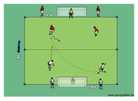
Field Preparation:
• 2 teams
• grid (25yds x 30yds)
• 2x goals with goalies
• cones to mark off area
• good supply of balls for continuous play
Description:
• play 2v2 with players from each team waiting on their goal line
• the game starts with a player making a pass across the middle line to a player from the other team
• next the other team plays the ball in

*Note This game will allow the players to work on passing in a small sided game situation. Players can work on wall passes and combination play.
The game also teaches 1 v 1, 2 v 1 and defending.

"Good coaches use the basic criteria of street soccer for their vision of grassroots development; they realize that these elements produce a natural process that gives the most efficient training for young kids."

E 25 min Game. Same every week with variations as per pages 3,4,5 and 6.
Roma House League Development Program
B Week 9 Theme Passing
Fun Game 5 min Knock Off
Description:
• 3v3 • teams score by knocking off balls which are placed on flat cones inside playing area
Adapt number of players or balls according to your team numbers.
Coaching Points:
• players should accelerate towards the ball
• constant movement • communication is vital
• good angle and distance of support to receive ball
• first touch • quick decision making
• accuracy over power

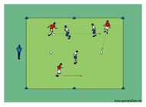
C Week 9 Passing 10 Min Technique
Description:
• each pair has a player start in opposite zones
• one pair starts in the middle zone
• players must stay in their designated zones
• partners try to pass to each other through the middle zone
• if a player in the middle zone intercepts a pass they switch roles with the pair that made the pass
• players in the outer zones must try to keep the ball in bounce
Coaching Points:
• angle, distance and timing of support
• vision • decision making
• verbal and visual communication
• accuracy • weight of pass • first touch
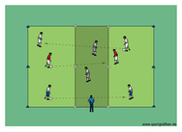

Roma House League Development Program
D Week 9 10 min Passing and Shooting
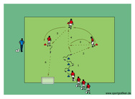
Description:
• players pass to each other in the sequence as shown
• last player shoots from distance into the mini goal
• two-touch passing
Variation:
• one-touch passing
• adjust spacing depending on the age and ability of the group
Coaching Points:
• weight of pass
• accuracy
• first touch
*Note Players rotate position.

The emphasis on winning is a detriment to young players because it prevents us from developing technically proficient players. And we're not giving them the ability to make decisions. You can't find a youth soccer game where the coaches aren't screaming the whole time, telling kids what they should do and how they should do it.'

E 25 min Game. Same every week with variations as per pages 3,4,5 and 6.

Roma House League Development Program
B Week 10 Theme Dribbling
Description:
• the player with the ball tries to dribble through as many cone goals as possible
• players cannot go through the same goal twice in a row
• if the defender wins ball, he gives it back to the attacker
• switch roles after approx. 45-60 seconds
• play for 2-3 rounds • player with most goals wins
Variation:
• play in teams (3v3 with one ball)
• if the defender wins the ball he is allowed to score
• if a player beats the defender with a move, he is awarded an extra point
Coaching Points:
Attacking:
• deception • set up defender • change of speed & direction • protect the ball • vision
Defending:
• control and restraint • delay and channel
• deny turn
Fun Game 5 min Dribbling gates game
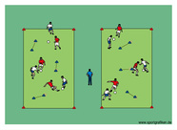
C Week 10 Dribbling 10 Min Technique
Dribble and Pass
Description:
• players dribble around cones as shown
• players follow their pass
Variation:
• specify how players must dribble (inside or outside of foot, sole, left or right foot only etc.)
• players perform a move in front of middle cone and then make a pass
• players make a self pass towards the middle cone, catch up with it and dribble around the cone and then pass and follow to the next player/cone
• adjust spacing depending on the age and ability of the group if necessary
Coaching Points:
• quick turn • close control • accurate pass to feet
• move towards ball when receiving • good first touch
• eye contact • weight of pass • accuracy
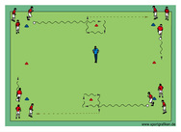
Roma House League Development Program
D Week 10 10 min Dribbling 1 v 1 attacking and Shooting
Description:
• players dribble through cone goal to take on defender in a 1v1 situation
• defender is allowed to enter through cone goal #2 once the attacker crosses through goal #1
• the defender cannot follow the attacker once he dribbles through cone goal #2
• next the attacker becomes the defender
Variation:
• defender only becomes an attacker if he wins the ball
• once the attacker dribbles through cone goal #2 he must finish on goal with his first touch
• adjust spacing depending on the age and ability of the group
Coaching Points:
• accuracy over power • eye on ball
• quality of preparation touch
• contact surface • aggressive and positive mentality
• change of direction and speed • deception
• set up defender • protect the ball • close control
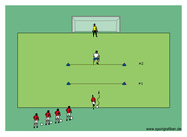

Words of wisdom…enjoy watching your children play soccer! Find something that they do well and cheer them on! What you say and how you say it is important to your child!

E 25 min Game. Same every week with variations as per pages 3,4,5 and 6.
Roma House League Development Program
B Week 11 Theme Dribbling
Fun Game 5 min Dodge Ball
Description:
• dribblers dribble inside playing area
• taggers freeze others by throwing and hitting their ball
• player whose ball is hit, picks it up and waits until a teammate unfreezes him by passing the ball through his legs
• switch taggers every 2-4 minutes
Variation:
• vary number of taggers
• player whose ball is hit becomes a tagger as well
• player whose ball is hit switches role with the tagger
• adjust spacing depending on the age and ability of the group
Coaching Points:
• accuracy • weight of pass
• quick decision making • change of direction and speed • deception • set up defender
• protect the ball • vision • close control
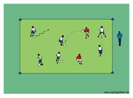
CWeek 11 Dribbling 10 Min Technique
Description: Driibbling Race. Speed
• each pair is assigned a station with a couple of cones to dribble around as shown
• players try to catch the player in front of them
• each player starts dribbling from a different cone
• players switch roles often
Variation:
• specify how players must dribble (inside or outside of foot, left or right foot only etc.)
• players dribble counter clockwise
• players can choose whether to go clockwise or counter clockwise
• players run with a ball in their hands as a warm up
• adjust spacing depending on the age and ability of the group if necessary
Coaching Points:
• agility and balance • contact surface of foot
• change of speed & direction • close control • soft touch
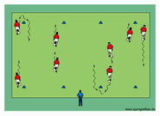
Roma House League Development Program
D Week 11 10 min Dribbling and Shooting
Dribbling 1 v 1 shooting drill.
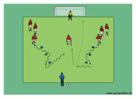
• first player in group (a) dribbles zig zag around cones and tries to hit the goalie
• same player now becomes the defender in a 1v1 against the player from group (b) who starts dribbling around cones shortly after the
player from group (a)

Variation. Ask players to use week foot or both feet.

Words of wisdom…enjoy playing small-sided games (1 against 1, 2 against 1, 2 against 2, etc.) with your children in the backyard. Don’t coach them…play with them and have FUN! Children love to play with their parents and show them what they can do.

E 25 min Game. Same every week with variations as per pages 3,4,5 and 6.

Roma House League Development Program
B Week 12 Theme Dribbling
Description:
• dribblers attempt to dribble to the opposite side without losing their ball
• 2-3 defenders start appr. 5 yards behind everyone else as shown
• dribbler whose ball is touched by a defender becomes a defender himself
• last dribbler with a ball wins
• play multiple rounds
Variation:
• specify how players must dribble (inside or outside of foot, left or right foot only etc.)
• dribblers switch defenders if they get tagged
• adjust spacing depending on the age and ability of the group if necessary
Coaching Points:
• change of speed & direction
• protect the ball • close control • head up

Fun Game 5 min Catch Me If You Can
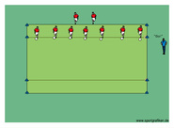
C Week 12 1 Dribbling 0 Min Technique
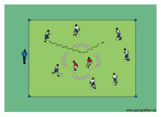
Description Dribbling Circle
• attacking players outside the circle attempt to dribble in and out of the circle to score a point
• attacking players cannot go in and out through same opening
• defending players inside circle attempt to block dribbler's path
• switch defenders often
Variation:
• vary number of defenders
• defenders attempt to knock out attacker's ball while keeping their own ball close
• defenders must carry a ball throughout activity
• adjust spacing depending on the age and ability of the group if necessary
Roma House League Development Program
D Week 12 10 min Passing, Dribbling and 1 v 1 Shooting
Description:
• defending player holds a ball in his hands
• defending player can only move sideways on goal line (Like A Balancing Act!)
• the ball is passed to the attacker who must dribble past the defender and finish with a shot on the mini goal on his first touch once he is
past the defender
• players switch roles if the defending player touches the attacker's ball with the ball in his hands (he cannot throw it)
Variation:
• first pass must be lofted
• defender can move towards attacker once he receives the pass
• adjust spacing depending on the age and ability of the group
Coaching Points:
• accuracy • first touch into space
• get defender off balance • decision making
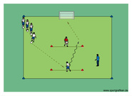

Coaching Points: Dribbling
• change of speed & direction
• vision
• close control
• awareness
• protect your ball
• deception

E 25 min Game. Same every week with variations as per pages 3,4,5 and 6.

